241801053- J B DHEJASVI- WTMA
EXP 10- To develop an Android application that: • Changes the font style of a TextView • Changes the text color • Displays a Toast message when a button is pressed

activity_main.xml
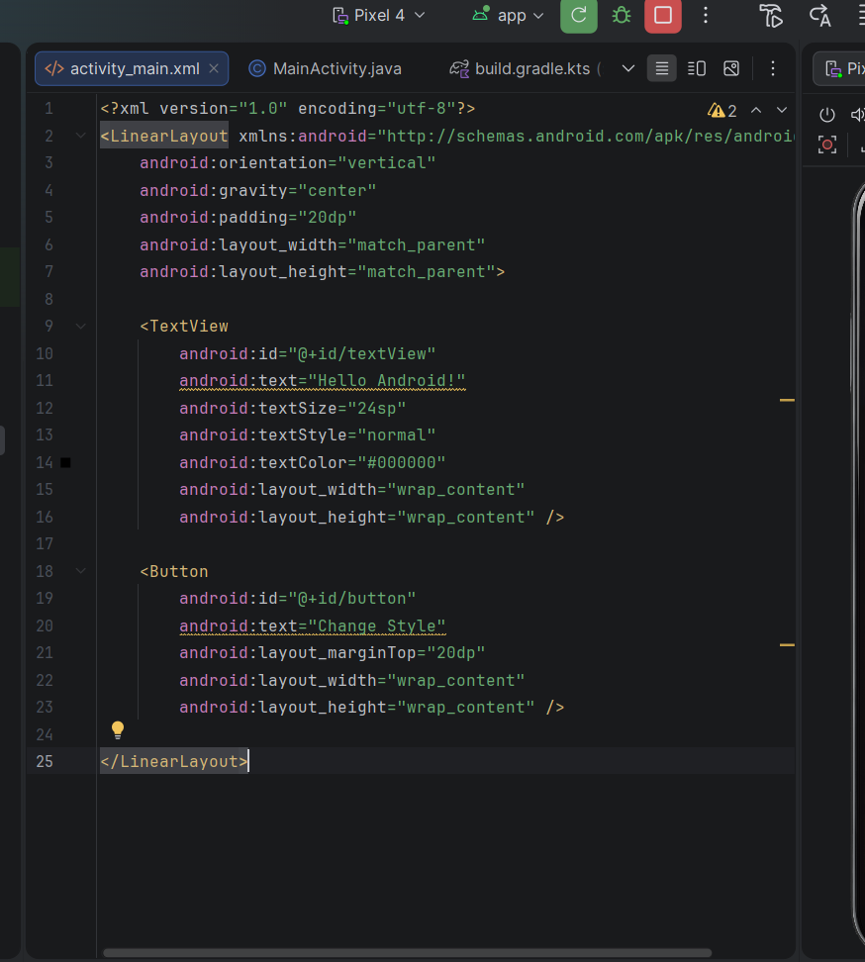
MainActivity.java
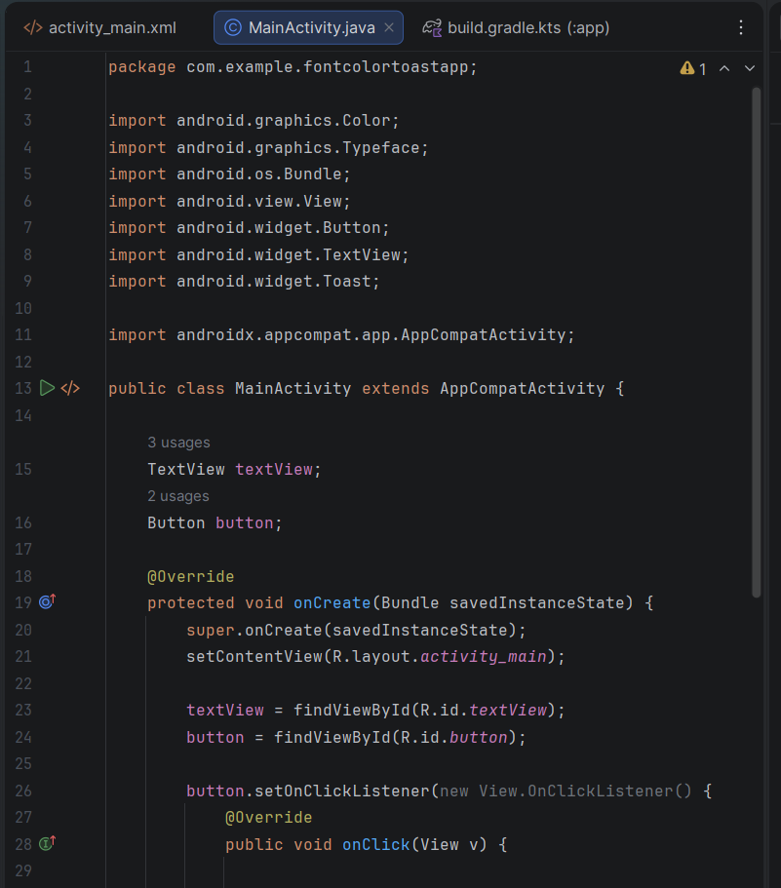
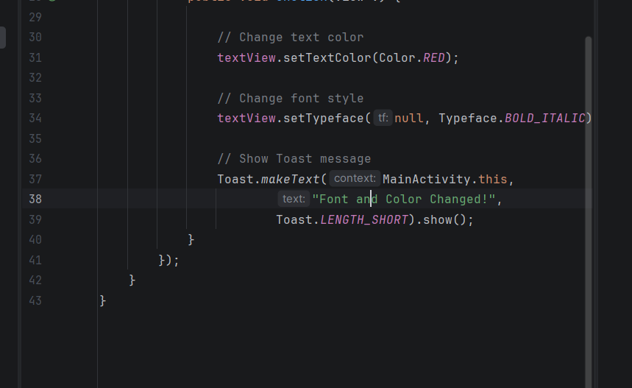
OUTPUT:
